Teaching science through stories
Children’s stories provide a great context for learning science. Explore our resource packages based around popular children’s books and discover the science hidden in a book. Resources include book summaries, hints and tips for teaching the science and further stories on a similar theme.
They are organised into three age groups:

5 -7 years
- HANDA'S SURPRISE
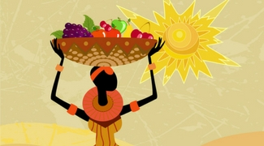
Handa's Surprise would make a great starting point about the needs of living things linked to diet and the specific needs of humans.
NEEDS OF LIVINGS THINGS, DIETS AND ANIMALS
- JACK AND THE BEANSTALK
The story of Jack and the Beanstalk makes a great starting point for teaching the topic of plants yo younger primary aged children.
PLANTS
- LITTLE RED RIDING HOOD
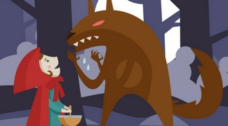
As Little Red Riding Hood is set in a wood, it makes a lovely starting point for finding out about habitats.
HABITATS AND FOOD CHAINS
- ONCE THERE WERE GIANTS
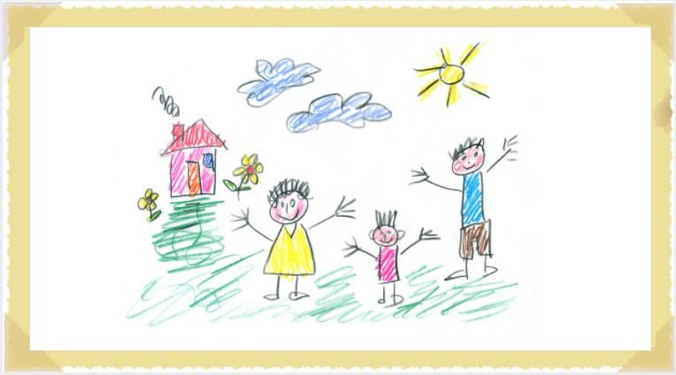
Support children to understand that all animals, including humans, have offspring which grow into adults.
ANIMALS INCLUDING HUMANS AND LIFECYCLES
- ONE YEAR WITH KIPPER
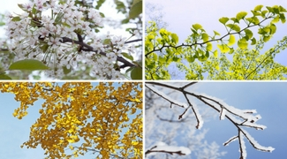
One Year with Kipper provides a nice link into work on Seasonal Change as children work to observe changes across the four seasons.
SEASONS AND WEATHER
- RSPB: MY FIRST BOOK OF GARDEN BIRDS
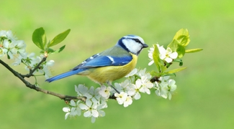
My First Book of Garden Birds helps to meet the objective to ​identify and name a variety of common birds.
- ​TADPOLE'S PROMISE
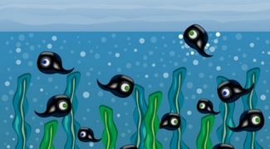
Tadpole's Promise is a great story to use when exploring life cycles and helping children to describe the difference in the life cycle of a mammal, an amphibian, an insect and a bird.
LIFECYCLES

- THE GRUFFALO
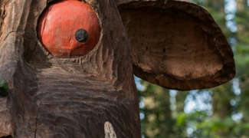
The Gruffalo can support children to learn more about habitats and to identify and name a variety of plants and animals in different habitats, including micro-habitats.
IDENTIFYING AND NAMING ANIMALS

- THE THREE LITTLE PIGS
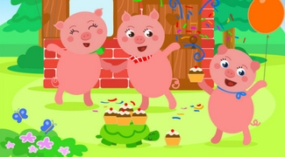
Help children to think about identifying different materials and considering what properties they have and how this suits them for different purposes.
MATERIALS AND THEIR USES

7 - 9 years
- CHARLIE AND THE CHOCOLATE FACTORY
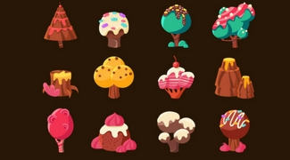
Charlie and the Chocolate Factory by Roald Dahl provides a good context to learn about states of matter.
STATES OF MATTER
- HORRID HENRY ROCKS
Horrid Henry Rocks is a great book to start teaching about sound and exploring how sounds are made.
SOUND

- THE FIREWORK-MAKER'S DAUGHTER
The Firework Maker’s Daughter by Philip Pullman is a good starting point for teaching about light.
LIGHT

- THE IRON MAN
The Iron Man is the perfect story to explain how magnets attract or repel each other and attract some material and not others.
FORCES AND MAGNETISM
- THE LITTLE MOLE WHO KNEW IT WAS NONE OF HIS BUSINESS
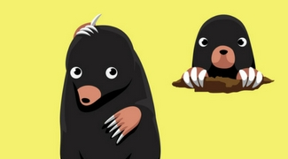
This funny tale creates a great setting through which children can explore simple functions of the basic parts of the digestive system in humans.
DIGESTION
- THE PEBBLE IN MY POCKET
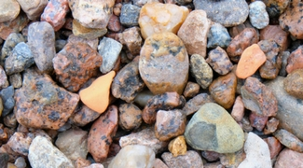
Pebble In My Pocket tells the dynamic story of rock formation; showing the reader the processes that the pebble goes through from its beginnings in a fiery volcano 480 million years ago.
ROCKS AND SOILS
- THE STORY OF FROG BELLY RAT BONE
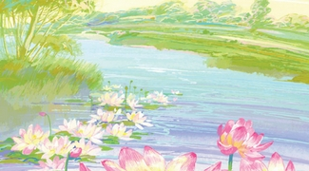
The story of Frog Belly Rat Bone provides a good setting for investigating plants and their benefits to our environment.
PLANTS

THE VANISHING RAINFOREST
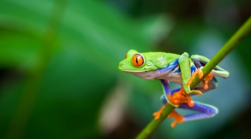
The Vanishing Rainforest by Richard Platt is a good book for looking at the human impact on the environment, in particular deforestation.
HUMAN IMPACT ON THE ENVIRONMENT
- WOLVES
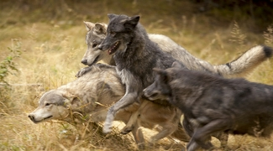
Wolves is a brilliant setting for constructing and interpreting a variety of food chains, as well as identifying producers, predators and prey.
FOODCHAINS

9-11 years
- BEETLE BOY
Beetle Boy provides a nice way to link to work on classification of invertebrates.
CLASSIFICATION
- CHARLOTTE'S WEB
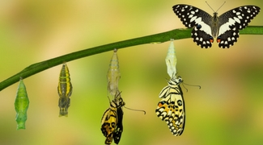
This is the perfect story to compare the lifecycles of different animals and plants.
LIFECYCLES

- PIG HEART BOY
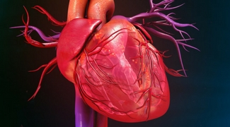
Pig Heart Boy provides a good setting for learning about the heart and circulation.
CIRCULATION

- GEORGE'S SECRET KEY TO THE UNIVERSE
Geroge's Secret Key to the Universe is a fun read and contains lots of factual sections for help with teaching about the solar system.
SOLAR SYSTEMS
- GOODNIGHT MR TOM
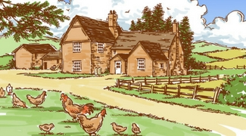
This wartime story is ideal for exploring the uses of electricity and how circuits work.
ELECTRICITY
- ITCH
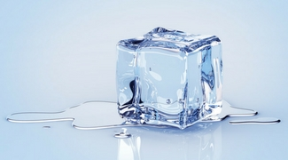
Itch is an action-backed story in which is great for finding out more about changes of state.
CHANGES OF STATE

- KENSUKE'S KINGDOM
Kensuke’s Kingdom is full of opportunities to explore properties of materials, you can even use the context of survival scenarios linked to the book.
PROPERTIES OF MATERIALS
- ONE SMART FISH
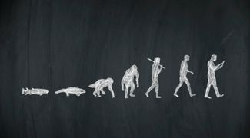
One Smart Fish by Christopher Wormell provides a meaningful context for learning about adaptations and evolution.
EVOLUTION AND INHERITANCE
- THE TIN SNAIL
The Tin Snail by Cameron McAllister provides a context for learning about forces and mechanisms, including levers, pulleys and gears.
FORCES AND ENGINEERING

